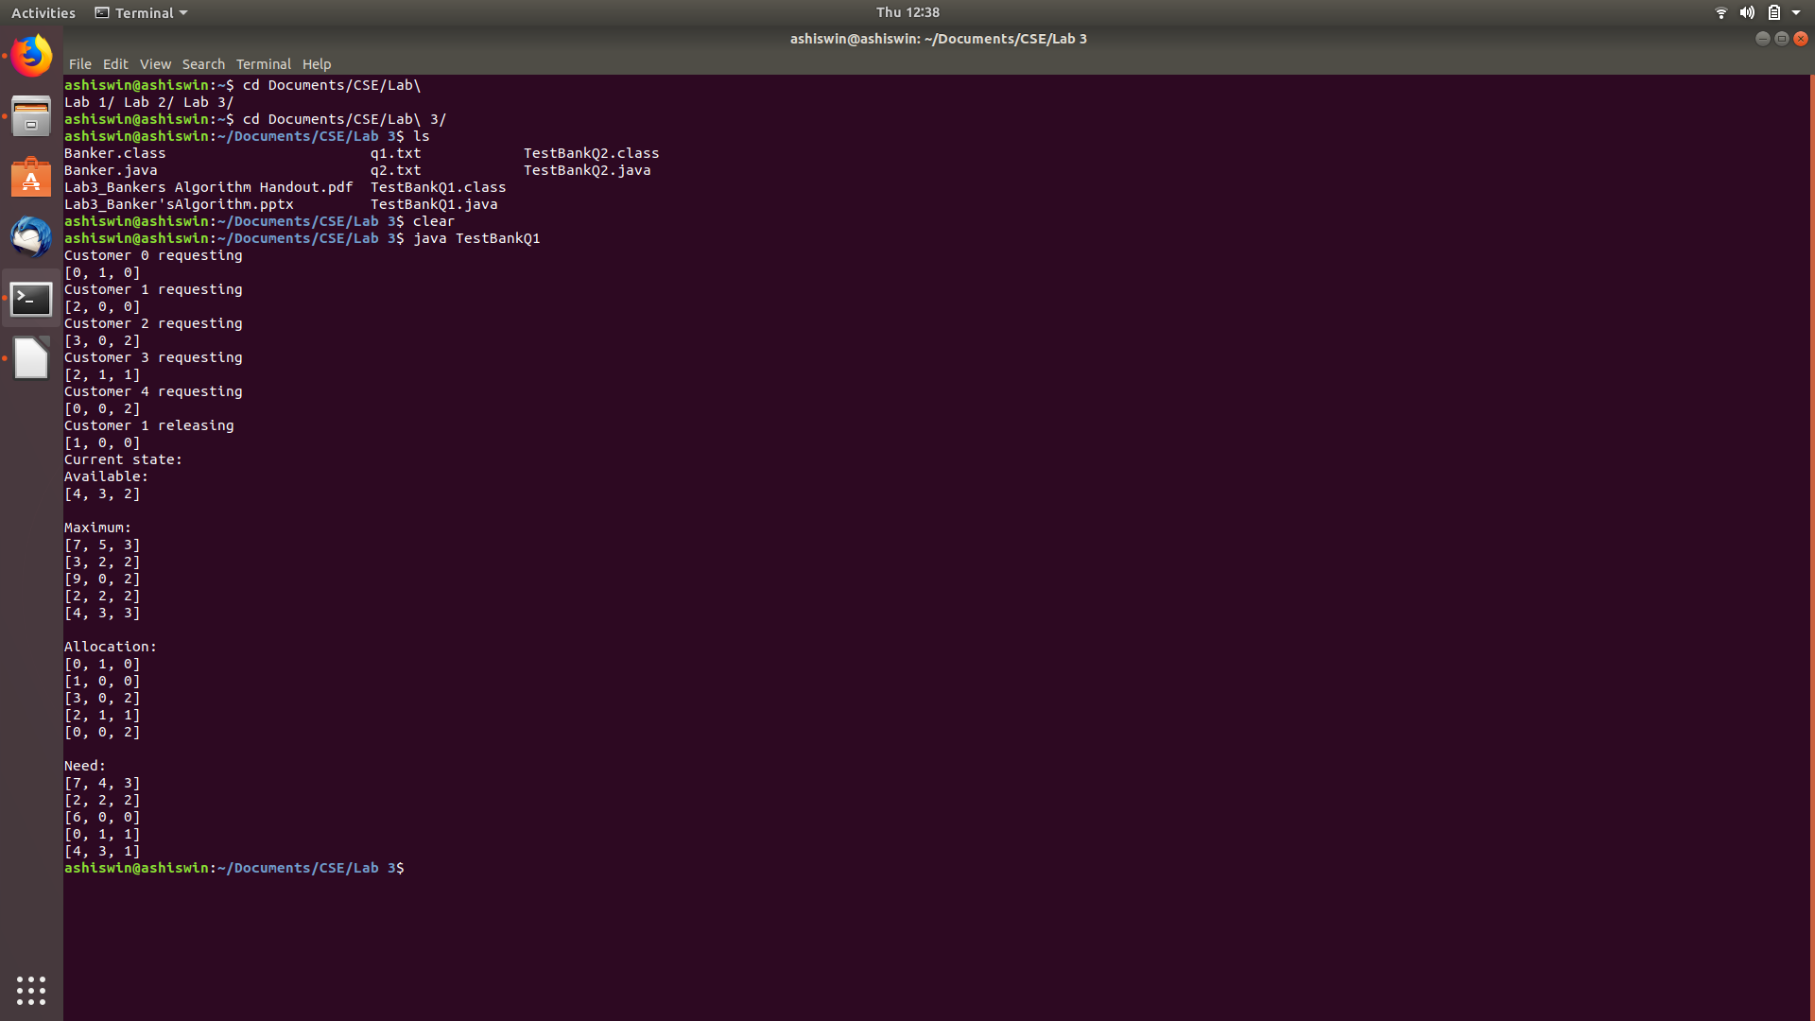

Question 1 Output

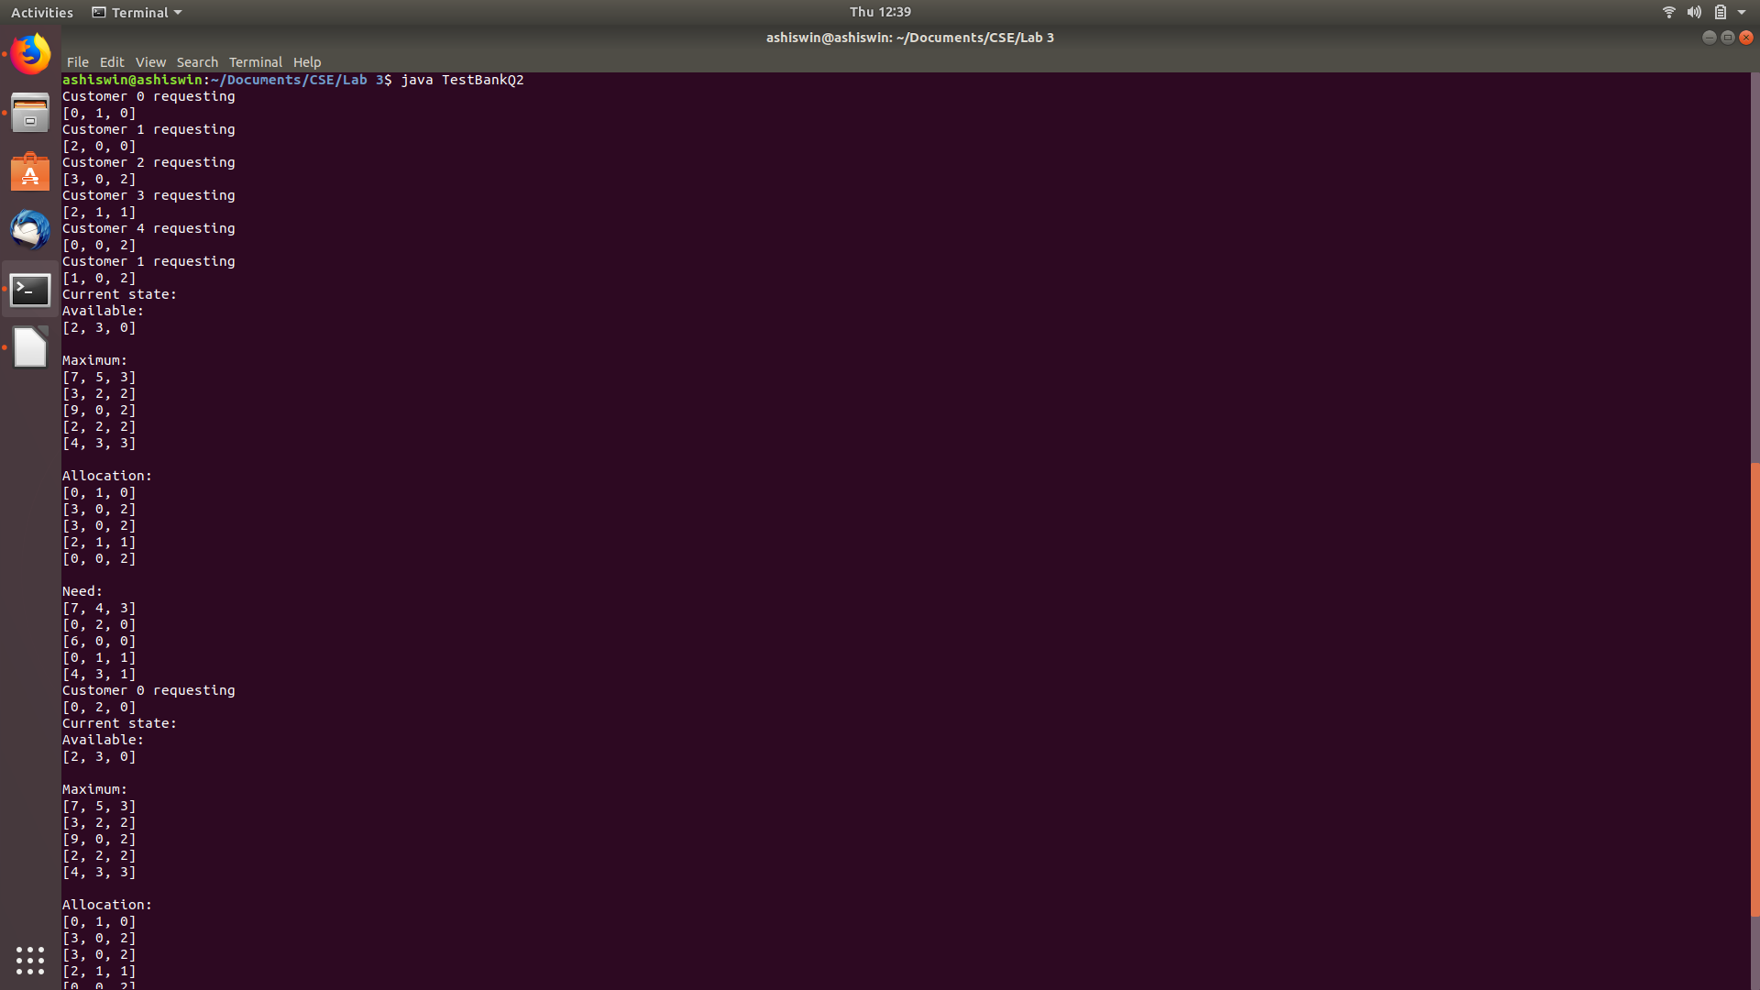

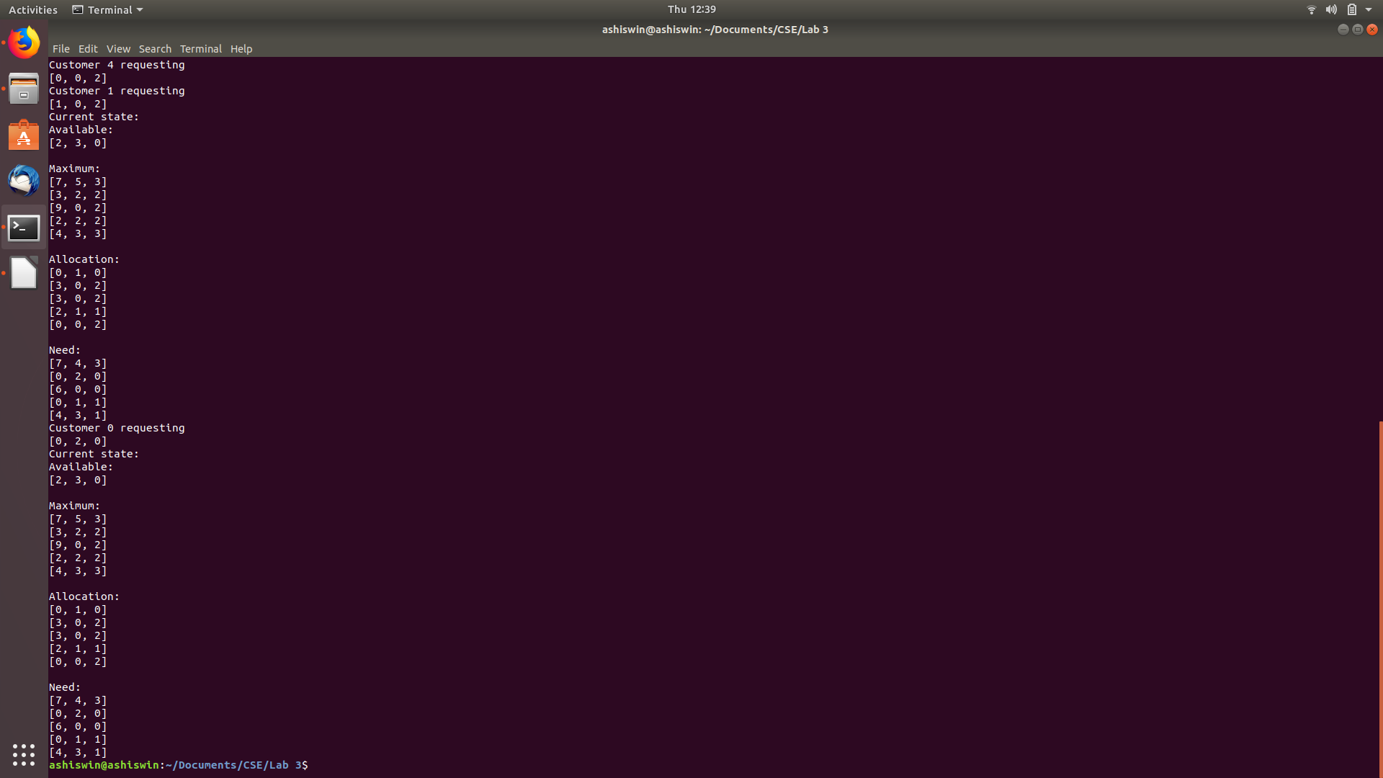

Question 2 Output

**Analysis of Algorithm**

This algorithm runs in O(n*n*m) or O((n^2)m).

This is because there is a nested for loop, which causes the nm runtime. This is then repeated in a while loop, causing it to be multiplied by n.